STANDARD FORMAT OF “LEHENGA DESCRIPTION”


For Online Selling Products
Design Name: UNIQUE-H
Product Colours NO.: H1
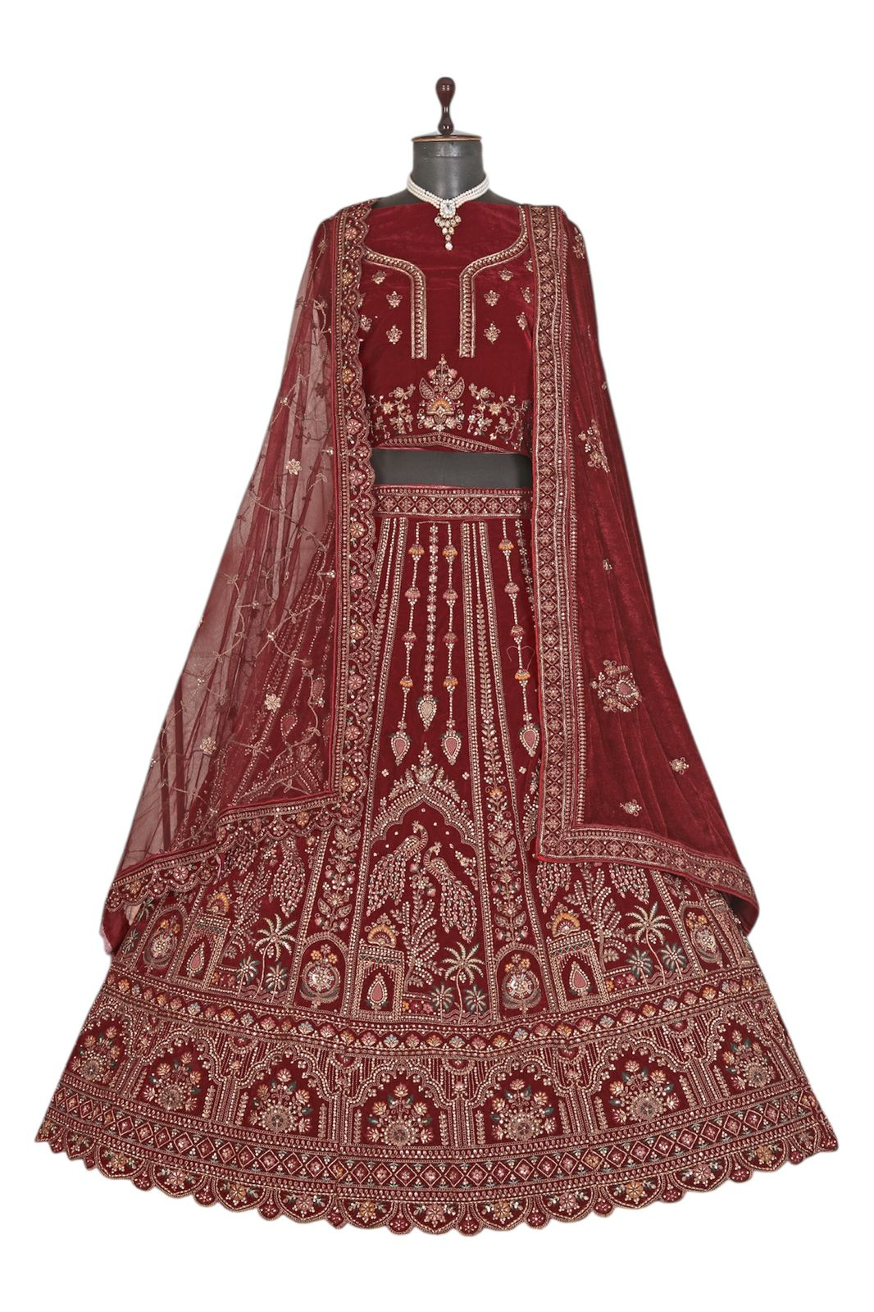
Particulars | Details
Lehenga Fabric | Premium Velvet
Blouse Fabric | Premium Velvet
Dupatta Fabric | - Net Dupatta  &  - Velvet Dupatta
Work Type | Heavy Zari, Stone & Sequin Embroidery Work
Colour | Bridal Maroon
Pattern | Bridal Designer
Stitching Type | Semi-Stitched (Can be customized up to 44")
Occasion | Wedding, Reception, Engagement & Festive Wear
Fit Type | Regular Fit
Care Instructions | Dry Clean Only
Package Contents | 1 Lehenga, 1 Blouse Piece, 2 Dupatta

KEY HIGHLIGHTS
- Crafted from luxurious velvet fabric ensuring rich texture and royal appearance
- Embellished with intricate zari and sequin embroidery for a stunning look
- Net dupatta enhanced with velvet border adds elegance and grace
- Perfect choice for weddings, receptions, and festive functions
- Semi-stitched design allows convenient fitting customization
- Lightweight yet grand, ensuring comfort for long hours of wear
- Blends traditional craftsmanship with modern bridal aesthetics

